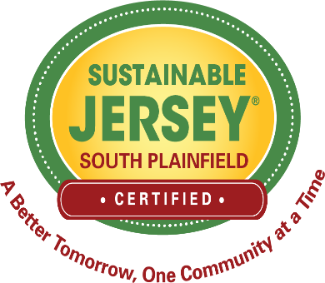
MEDIA RELEASE

FOR IMMEDIATE RELEASE: November 29, 2022
Contact: A. Tempel 908.226.7621 atempel@southplainfieldnj.com

South Plainfield Certified by Sustainable Jersey at the Bronze-Level

South Plainfield, NJ – Sustainable Jersey representatives announced that the Borough of South Plainfield has met the rigorous requirements to achieve Sustainable Jersey certification at the bronze-level for the fourth time. South Plainfield is one of 81 municipalities that have attained certification in 2022. The certified towns were announced at the Sustainable Jersey Annual Luncheon on November 15th in Atlantic City at the New Jersey State League of Municipalities Conference. Sustainable Jersey's participating communities represent over 82% of the state's municipalities.

To become Sustainable Jersey certified, South Plainfield submitted documentation to show it had completed a balance of the required sustainability actions, worth at least 150 action points. In addition to reaching 150 points, each certified community had to create a green team and select at least two out of fourteen priority action options. South Plainfield earned 160 points and did two of the fourteen priority actions by completing a sustainable land use pledge and a prescription drug safety and disposal action.

“The Sustainable Jersey certified municipalities demonstrate sustainability excellence. The annual awards event is a celebration of their accomplishments,” said Randall Solomon, director of Sustainable Jersey. “As New Jersey faces issues such as the climate crisis, a growing equity divide and environmental pollution, the certified towns exemplify the commitment we need to accelerate the transition to a sustainable New Jersey.” Certified towns excelled in areas such as improving energy efficiency, health and wellness, reducing waste, sustaining local economies, protecting natural resources and advancing the arts.

South Plainfield’s Green Team has documented actions dealing with Animals in the Community, Arts and Creative Culture, Community Education and Outreach, Energy Efficiency, Green Design, Health and Wellness, Land Use, Natural Resources, Sustainability and Climate Planning and Waste Management. Current efforts are directed at promoting solar energy, evaluating the diversity of the Borough’s boards and commissions, establishing a Creative Team, stopping unnecessary motor vehicle idling and educating about stormwater management. Anyone interested in learning more about the Green Team and ways to become involved should contact Bob Longo, the Green Team Chair, at longo@CornerstoneAG.com.

About Sustainable Jersey
Sustainable Jersey provides tools, training and financial incentives to support communities as they pursue sustainability programs. Sustainable Jersey participants (municipalities and schools) have successfully implemented and documented over 23,467 sustainability actions. Sustainable Jersey has provided over $7.2 million in grants to municipalities, school districts and schools for community-based projects that create healthy and sustainable communities in New Jersey.

Website: www.SustainableJersey.com; www.SustainableJerseySchools.com
Twitter: https://twitter.com/sj_program; https://twitter.com/sj_schools
Facebook: www.facebook.com/SustainableJersey
Instagram: https://instagram.com/sustainable_jersey/
Linked In: https://www.linkedin.com/company/sustainable-jersey

###

